NAME: S.PRATIBA
ROLL No: 241901080

EXPERIMENT 3
PERFORM SESSION HIJACKING USING VARIOUS TOOLS

AIM:
To understand and demonstrate session hijacking in an authorized lab environment using Ettercap and Wireshark.

TOOLS REQUIRED:
- Kali Linux: Used as the monitoring and testing machine.
- Metasploitable2: Vulnerable target machine hosting the DVWA web application.
- VirtualBox: Used to run Kali Linux and Metasploitable2 in an isolated lab network.
- Wireshark: Used to capture and analyse network traffic.
- Mozilla Firefox: Used to access DVWA and inspect browser storage.
- DVWA (Damn Vulnerable Web Application): Used as the intentionally vulnerable web application for session security testing.
- Terminal utilities: ip a, ifconfig, and ping to identify IP addresses and verify connectivity.

PROCEDURE:
- Start Kali Linux and Metasploitable2 in VirtualBox and ensure both machines are connected to the same isolated host-only network.
- Identify the IP addresses of both machines using the following commands:
Kali Linux: ip a
Metasploitable2: ifconfig
- Verify connectivity between the machines using the ping command:
ping -c 4 192.168.56.102
- Open Wireshark in Kali Linux and start capturing packets on the eth0 network interface.
- Apply the display filter http to observe HTTP requests and responses generated while accessing the target web server.
- Open the DVWA application hosted on Metasploitable2 using Firefox and log in to the application.
- Open Firefox Developer Tools and navigate to Storage → Cookies to inspect the DVWA session cookie and its security attributes, without exposing or reusing the session token.
- Record the observed network traffic, session cookie attributes, and security implications of transmitting session information over unencrypted HTTP.
- Analyse the observations and document the security risks associated with session hijacking and possible preventive measures.

OBSERVATION:
OBSERVATION | RESULT
Kali Linux IP address | 192.168.56.101
Metaspoitable2 IP address | 192.168.56.102
Network connectivity | Successful; 4 packets received with 0% packet loss
Wireshark packet capture | HTTP GET requests and HTTP 200 OK responses observed
Test application | DVWA opened successfully; loged in as admin
Session cookie | PHPSESSID observed in Firefox Storage
Cookie security attributes | HttpOnly: false; Secure: false; Samesite: None, displayed in the captured screenshot
Session hijacking | No
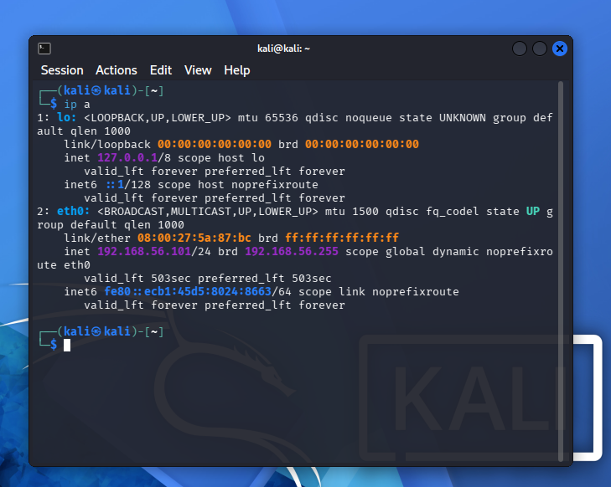
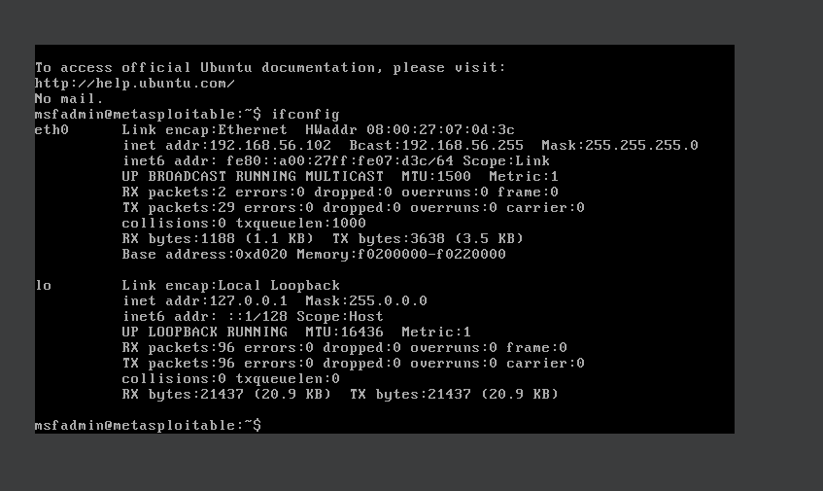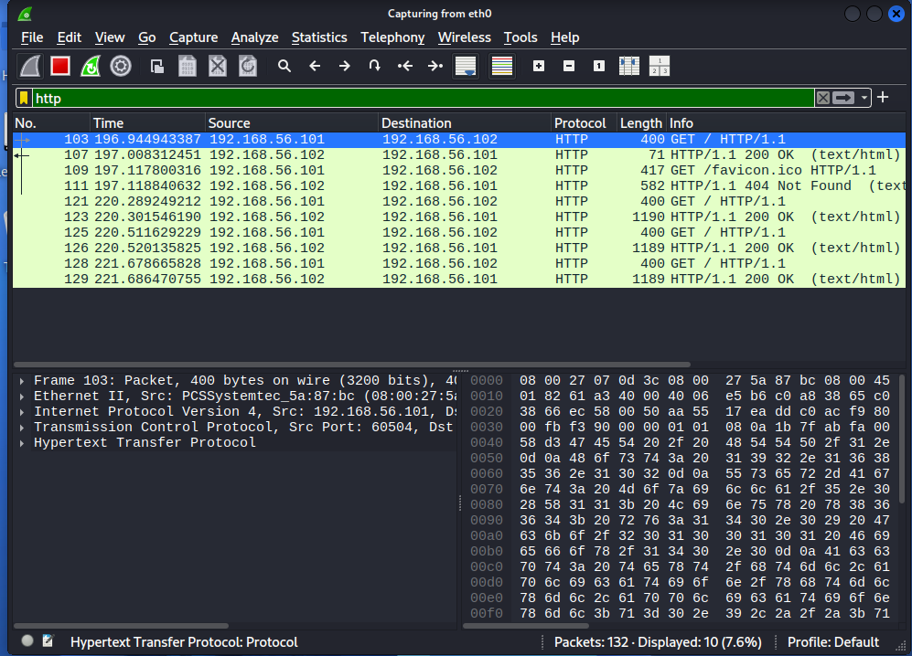
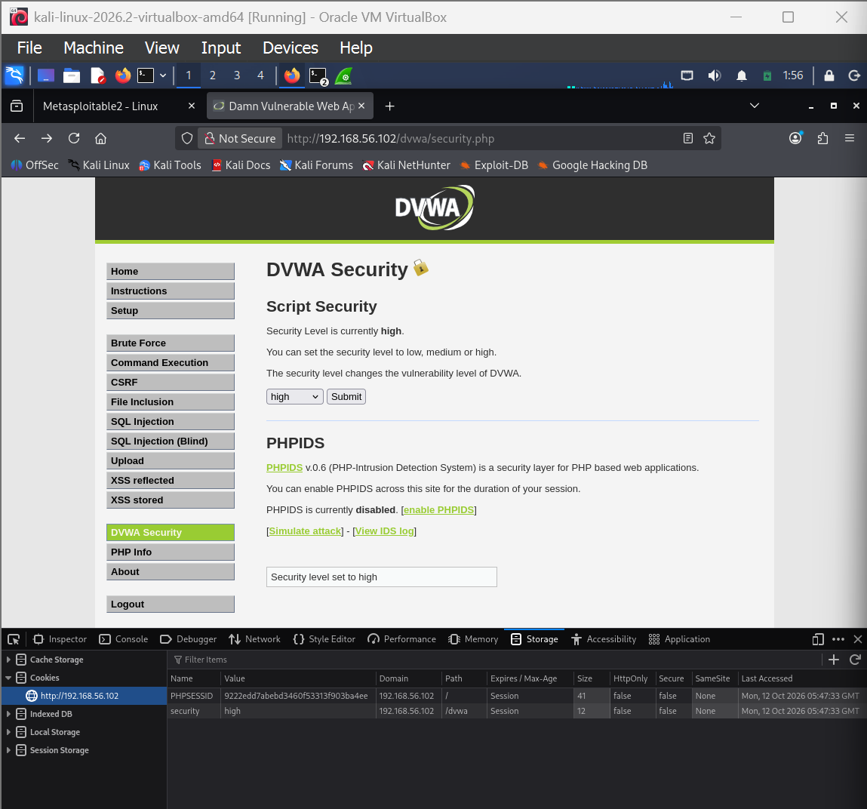

RESULT:
HTTP traffic was captured and analysed using Wireshark. The DVWA session cookie and its security attributes were inspected using Firefox Developer Tools, and the security risks associated with session hijacking were studied.

